The Northeast Victorian Studies Association presents

RECOVERY

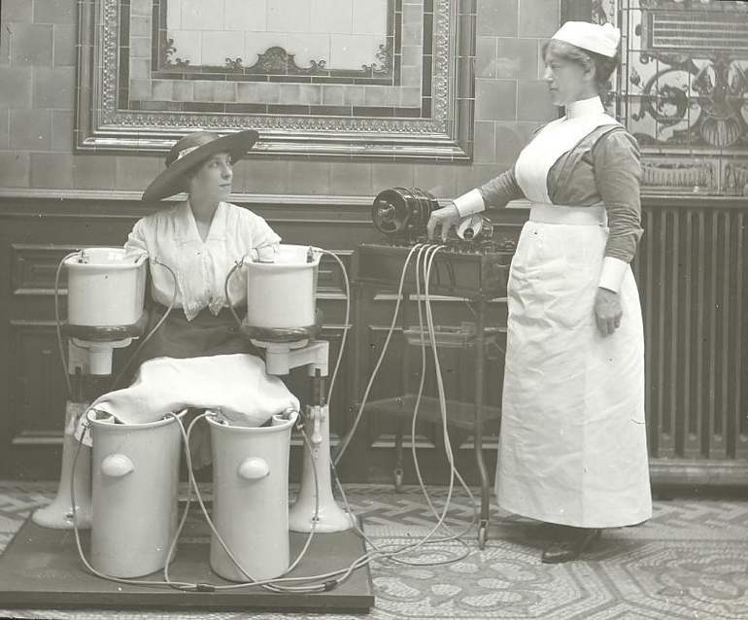
Johns Hopkins University
April 8-10, 2022

NVSA Officers
President: Jonathan Farina (Seton Hall University)
Vice-President: Olivia Loksing Moy (CUNY-Lehman)
Treasurer: Joan Dagle (Rhode Island College)
Historian: Anne Humpherys (CUNY)

NVSA Advisory Board
Eileen Gillooly, Anne Humpherys, George Levine, Tricia Lootens, Lisa Rodensky, Tyson Stolte, and Martha Vicinus

Conference Site Organizer
Jesse Rosenthal (Johns Hopkins University)

Conference Committee
James Eli Adams, Maeve Adams, Jacqueline Barrios, Jonathan Farina, Debra Gettelman, Erik Gray, Beth Hightower, Jonathan Loesberg, Tricia Lootens, Olivia Loksing Moy, Mary Mullen, Cornelia Pearsall, Simon Reader, Jesse Rosenthal, Jason Rudy, Jonah Siegel, Justin Thompson, Mimi Winick (committee chair), and Daniel Wright

Mentorship Program Director
Daniel Wright (University of Toronto)

Fellows
Jungah Kim (Texas A&M), Cherrie Kwok (U of Virginia), Joisip Martincic (Exeter), Shyam Patel (UC Irvine), Oishani Sengupta (U of Rochester), Dana Shaaban (Texas Christian), and Olivia Xu (Northwestern)

Mentors
Tanya Agathocleous, Sukanya Banerjee, Sarah Gates, David Kurnick, Grace Lavery, Tricia Lootens, Jason Rudy, Talia Schaffer, and Greg Vargo

Expanding the Field Essay Prize Winners
2022: Suvendu Ghatak (U of Florida), “Malaria and the Politics of Time: Diagnostic Realism and Palliative Fantasy in Trailokyanath Mukhopadhyay’s Kankabati”;
Honorable Mention: Imogen Forbes-Macphail (UC Berkeley), “Indian Algebra and Mathematical Style.”

2021: Diana Rose Newby (Columbia); Honorable Mentions: Corbin Hiday (U of Illinois at Chicago)) and Meghna Sapui (U of Florida)

2020: Lindsay Wells; Honorable Mention: Gavi Levy Haskell

2019: Erica Kanesaka Kalnay; Honorable Mentions: Erin Akerman and Patrick Mahoney

Expanding the Field Essay Prize Committee
Sophia Hsu (Chair), Alicia Christoff, Lorenzo Servitje, and Menglu Gao

Sonya Rudikoff Award Committee
Olivia Loksing Moy (Chair), Talia Schaffer, Jonathan Farina, Michael Tondre, Jonah Siegel

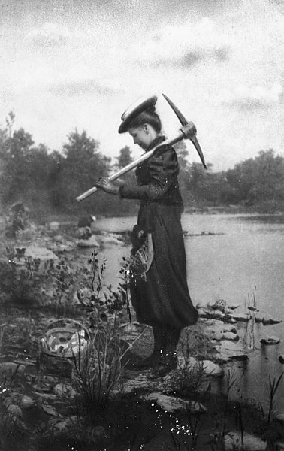
Zonia Baber collecting fossils

Special thanks for the support and co-sponsorship of:
Johns Hopkins University
The Alexander Grass Humanities Institute
Department of English
Special thanks to Sally Hauf

Friends of NVSA …
We all thank a group of extraordinarily generous friends of NVSA, including several longtime members, who donate consistently and substantially throughout the year.

Friday, April 8

All Panels will take place in Maryland Hall 110, 3400 N. Charles St. Baltimore, MD

2:00pm (and following) Registration
2:00pm Welcome
2:15–4:15pm Panel 1: Recovery from Imperialist Gender Norms
Simon Reader (CUNY-Staten Island), Chair

Sourav Chatterjee (Columbia), “Basantak or the Bengali Punch and Making of New Image-Texts in Late Colonial Bengal”
Natalie McGartland (U of Maryland College Park), “Land-based feminisms in Australian women’s writing”
Meghna Sapui (U of Florida), “Educating Colonial Tastes: Young Bengal’s Gastropoetical Mimicry”

4:15–4:30pm Coffee

4:30–6:00pm Panel 2: Medical Humanities
James Eli Adams (Columbia), Chair

Haejoo Kim (Seoul National), “The Syphilitic Child and the Fiction of the Individual vs. the Public in Victorian Anti-vaccination Debates”
April Patrick (Fairleigh Dickinson), “’Recovery is Very Rare’: Victorian Doctors on Breast Cancer Outcomes”
Kristin Samuelian (George Mason), “Waste: Disordered Eating, Anxiety, and Recovery in Great Expectations”
Tamara Silvia Wagner (Nanyang Technological), “Dangerous Signs of Recovery: Representing Relapses in Victorian Popular Fiction”


6:00-7:00 pm Drink Reception
Gilman Atrium, Gilman Hall

7:00 pm Dinners in Groups or on your Own
Sign up for group dinners at various local restaurants using the QR code above. (Cost not included).

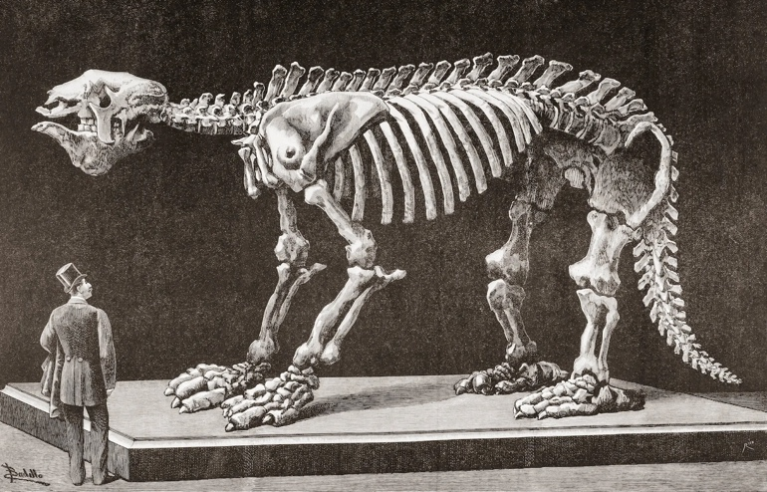

Megatherium americanum, or giant ground sloth, a species endemic to South America, in an 1892 illustration of a museum in Madrid in the 19th century. Credit: Classic Image/Alamy

Saturday, April 9

10:00am–12:00pm Keynote Panel in Honor of Carole Silver
Jonathan Farina (Seton Hall University), Chair

Arden Hegele (Columbia)
Talia Schaffer (Queens College, CUNY)
Rachel Adams (Columbia)

12:00-1:45pm Lunch Meeting
Busboys and Poets 3224 St. Paul Street, Baltimore, MD, 21218 Elijah Cummings Room

2:00–4:00pm Panel 3: Politics of Recovery
Maeve Adams (Manhattan College), Chair

Shyam Patel (UC Irvine), “The Loss of Loss Itself’: Utilities of Suffering in Oscar Wilde’s Prison Writings”
Greg Vargo (NYU), “Dramatizing Crisis and Recovery: The Dorchester Labourers and the Politics of Mutual Aid”
Deborah Denenholz Morse (William & Mary), “Frederick Douglass and ‘The House of Trauma’: A Reparative Reading of Emily Brontë’s Wuthering Heights as Transatlantic Abolitionist Text”
Diana Rose Newby (Columbia), “Harriet Martineau’s Vitalist Turn”

4:00–4:30pm Coffee

4:30–6:00pm Panel 4: Acts of Recovery
Jonah Siegel (Rutgers New Brunswick), Chair

Jacob Romanow (Rutgers New Brunswick), “Pyrrhic Canonicity: Thackeray and Failed Revivalism”
David Russell (Oxford), “On Getting Better: Ruskin, Stokes and Milner”
Herbert Tucker (Virginia), “Recovery Intransitive and Transitive: Tennyson and Browning”

7:00–9:00pm Book Launch and Dinner Banquet
Woodberry Kitchen, 2010 Clipper Park Rd, Baltimore, MD 21211

Pre-dinner Book Launch celebrating Communities of Care: The Social Ethics of Victorian Fiction (Princeton UP 2021) by Talia Schaffer

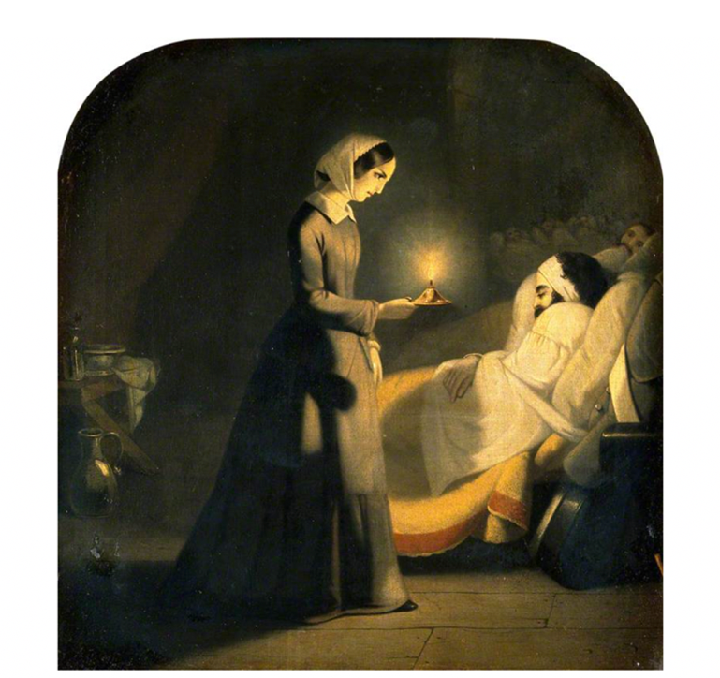Florence Nightingale as the Lady with the Lamp
Attributed to J. Butterworth, active 1839-1854

Sunday, April 10

9:00–10:15am Fieldwork: Engaging with Difficult Materials in Victorian Studies
Jason Rudy (U Maryland College Park) and
Adrienne Munich (SUNY Stonybrook), Co-Chairs

Jacqueline Barrios (U of Arizona at Tucson)
Manu Chander (Rutgers Newark)
Jessie Reeder (SUNY Binghamton)
Erin Spampinato (Southern Maine)

10:15–10:30am Coffee

10:30–12:00pm Panel 5: Colonial Time and Decolonization
Esther Hu (Boston University), Chair
Nasser Mufti (U of Illinois at Chicago), “Disciplining and Punishing Victorian Studies”
Shannon Neal (U Maryland College Park), “Demanding Stories: Settler Colonial Guilt in the Face of Indigenous Australian Silence and Trauma”
Brian Reinken (Rutgers New Brunswick), “‘It was no more fossil than I am’: Fossil Recovery and Renewable Energy in Late-Victorian Fiction”
Oishani Sengupta (U of Rochester), “Africa Redux: The Victorian Legacies of Chander Pahar”

12:00–1:00pm Conference Wrap-Up
Debra Gettelman (Holy Cross)
Justin Thompson (U of Maryland College Park)

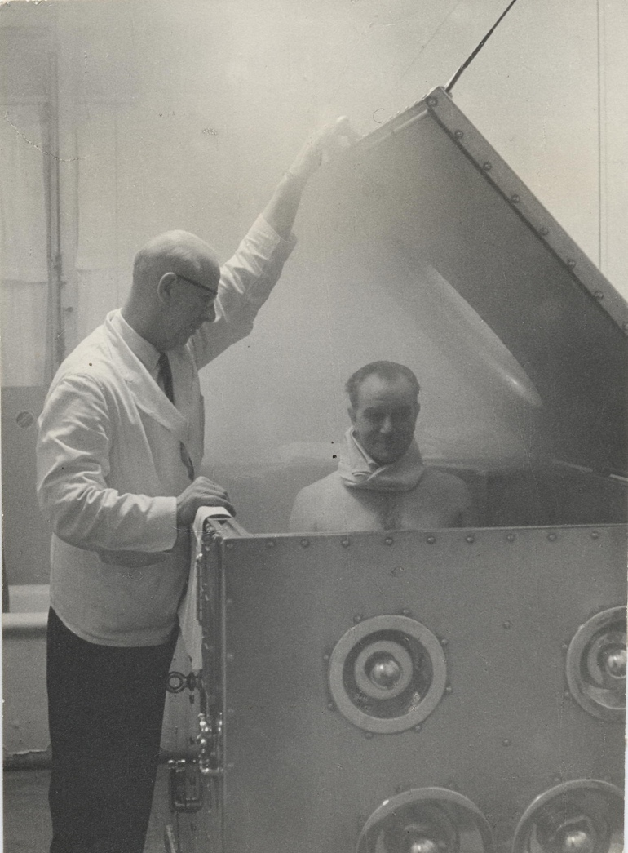
Patient undergoing Steam Bath (vapour) treatment.
© Bath and North East Summerset Council
Winners of the NVSA Sonya Rudikoff Prize
The Sonya Rudikoff prize for the best first book in Victorian Studies was established by the Robert Gutman family in honor of Mr. Gutman’s late wife. Sonya Rudikoff was an active member of the Northeast Victorian Studies Association and a recognized scholar. Her book, Ancestral Houses: Virginia Woolf and the Aristocracy, was published posthumously.

1999 Yopie Prins, Victorian Sappho (Princeton)
2000 Alison Winter, Mesmerized: Powers of Mind in Victorian Britain (Chicago)
2001 Jonah Siegel, Desire and Excess: the Nineteenth-Century Culture of Art (Princeton)
Honorable Mention: Rick Rylance: Victorian Psychology and British Culture 1850-1880 (Oxford)
2002 Nicholas Dames, Amnesiac Selves: Nostalgia, Forgetting, and British Fiction, 1810-1870 (Oxford)
2003 Priya Joshi, In Another Country: Colonialism, Culture, and the English Novel in India (Columbia)
2004 Seth Koven, Slumming: Sexual and Social Politics in Victorian London (Princeton) and
Alex Woloch, The One vs. The Many: Minor Characters and the Space of the Protagonist in the Novel (Princeton)
Honorable Mention: Andrew Warwick, Masters of Theory: Cambridge and the Rise of Mathematical Physics (Chicago)
2005 Suzy Anger, Victorian Interpretation (Cornell)
2006 Patrick O’Malley, Catholicism, Sexual Deviance, and Victorian Gothic Culture (Cambridge)
2007 Amanda Claybaugh, The Novel of Purpose: Literature and Social Reform in the Anglo-American World (Cornell)
2008 Chris Otter, The Victorian Eye: A Political History of Light and Vision in Britain, 1800-1910 (Chicago) and
Cornelia Pearsall, Tennyson’s Rapture: Transformation in the Victorian Dramatic Monologue (Oxford)
2009 Rachel Teukolsky, The Literate Eye: Victorian Art Writing and Modernist Aesthetics (Oxford)
2010 Sukanya Banerjee, Becoming Imperial Citizens: Indians in the Late-Victorian Empire (Duke)
2011 Sadiah Qureshi, Peoples on Parade: Exhibitions, Empire, and Anthropology in Nineteenth-Century Britain (Chicago) and
Charles LaPorte, Victorian Poets and the Changing Bible (Virginia)
2012 David Kurnick, Empty Houses: Theatrical Failure and the Novel (Princeton) and
Meredith Martin, The Rise and Fall of Meter: Poetry and English National Culture, 1860-1930 (Princeton)
2013 Jennifer Esmail, Reading Victorian Deafness: Signs and Sounds in Victorian Literature and Culture (Ohio University) and
Ross Forman, China and the Victorian Imagination: Empires Entwined (Cambridge)
2014 Allen MacDuffie, Victorian Literature, Energy, and the Ecological Imagination (Cambridge)
Honorable Mention: Kathleen Frederickson, The Ploy of Instinct: Victorian Sciences of Nature and Sexuality in Liberal Governance (Fordham)
2015 Annmarie Drury, Translation as Transformation in Victorian Poetry (Cambridge)
Honorable Mention: Jordan Bear, Disillusioned: Victorian Photography and the Discerning Subject (Pennsylvania State)
2016 Jesse Oak Taylor, The Sky of Our Manufacture: The London Fog in British Fiction from Dickens to Woolf (Virginia)
Honorable Mention: Elisha Cohn, Still Life: Suspended Development in the Victorian Novel (Oxford)
2017 Benjamin Morgan, The Outward Mind: Materialist Aesthetics in Victorian Science and Literature (Chicago)
Honorable Mention: Jonathan Farina, Everyday Words and the Character of Prose in Nineteenth-Century Britain (Cambridge)
2018 Emily Steinlight, Populating the Novel: Literary Form and the Politics of Surplus Life (Cornell University Press)
Honorable Mention: Nasser Mufti, Civilizing War: Imperial Politics and the Poetics of National Rupture (Northwestern University Press)
2019 Alicia Mireles Christoff, Novel Relations: Victorian Fiction and British Psychoanalysis (Princeton University Press)
2020 To be announced at the Dinner Banquet on
April 9, 2022!
NVSA: Our History
The Northeast Victorian Studies Association grew out of an interdisciplinary Five-College Victorian Studies Seminar (comprised of scholars from Amherst, Hampshire, Mount Holyoke, Smith, and the University of Massachusetts Amherst) initiated by Michael Wolff in 1970. In 1971, Woolf and Maurianne Adams hosted a conference on “England in the 1870s: A Decade of Conflict.” Other meetings, one on poverty, another on William Morris, followed.

At a 1975 conference on “The Victorian Family” hosted by Assumption College in Worcester, the organization of NVSA—with its primary task the sponsorship of annual conferences—was proposed. The next year, at the Ramapo College meeting on “Pasts and Futures,” the NVSA constitution was approved: Maurianne Adams became the first president and Robert Keane, the secretary-treasurer.

Highlights from succeeding conferences include a reconsideration of Walter E. Houghton’s landmark study, The Victorian Frame of Mind (1984), a spiritualist demonstration by a member of the London Psychical Research Society (1985), a descent into an actual coalmine at the “Victorian Others” conference at Scranton College (1988), a professional production of Princess Toto by W.S. Gilbert and Frederic Clay (1992), and a magic lantern show (2008). In 1991, at the University of Rochester meeting, we honored George Ford, a longtime supporter of NVSA, for a lifetime of contributions to Victorian studies.

1989 saw the establishment of the Coral Lansbury Award, honoring the memory of our third president, to help support the travel of a graduate student presenting a paper; in 1993 another such award, in memory of George Ford, was created. In 1999, the Rudikoff family established a prize for the year’s best first book on Victorian subject as a memorial to Sonya, a longtime member. Meanwhile, in 1995 Glenn Everett designed the organization’s first website.

The organization has alternated conference sites between the northern and southern reaches of the “northeast,” including Canadian venues. There is a reception on Friday evening and a Saturday night banquet and entertainment. The Saturday business lunch is an important occasion, featuring a lively debate and vote on the choice of the next year’s conference topic. In 1996, the Sunday afternoon tour became a Friday afternoon visit to a library collection, a museum, or some other local site. In 1999, the keynote talk evolved into a Saturday morning keynote panel, featuring several speakers and addressing such topics as “Future Directions for Victorian Studies” (1999), “Interdisciplinarity at the Breaking Point” (2000), “Periodization and the Nineteenth Century (2001), and “Knowing the Past” (2002). Panels have included “Victorian Cosmopolitanism” with Antoinette Burton, James Buzard, and Bruce Robbins (2007); “Systems and Archives” with Paul Saint-Amour, Nicholas Daly, Bernard Lightman, and Catherine Robson (2011); and “Victorian Senses” with Janice Carlisle, William Cohen, and Jules Law (2014). Our 2015 conference at the University of Rhode Island included a 40th anniversary retrospective panel featuring long-term NVSA members.

In 2019, we returned to our original site in Amherst and celebrated a new mentorship program and an essay award to encourage and increase the demographic, methodological, and intellectual diversity of NVSA, which aspires to be as extraordinarily welcoming and inclusive as it is intellectually rigorous and innovative. We renamed the pedagogy panel “Fieldwork” to focus it on current intellectual concerns in the field. The Covid-19 pandemic postponed the 2020 conference to 2021, when we held a virtual but engaging discussion of “Oppression and Uprisings.” We are delighted to resume our in-person conference in 2022 at Johns Hopkins University, which has played an important role in steering the country through the pandemic. But we regret that many friends still cannot be with us because “Recovery” is ongoing.

NVSA Conferences

1975 The Victorian Family (Assumption College)
1976 Pasts and Futures (Ramapo College)
1977 Crime and Punishment (Boston College)
1978 Victorians and the World Abroad (Hofstra University)
1979 Victorian Mythologies (Rhode Island College)
1980 Victorian War and Violence (University of Pennsylvania)
1981 Britain in the 1880s (University of Hartford)
1982 Victorians and Money (Drew University)
1983 Loss and Failure in the Victorian World (Boston College)
1984 Framing the Victorians (Hofstra University)
1985 The Victorians and the Supernatural (Rhode Island
College and Brown University)
1986 Victorian Work and Workers (Yale Center for British Art)
1987 Victorian Food, Fun, and Games (Wheaton College)
1988 Victorian Others (Scranton College)
1989 Evolution and Revolution (Rhode Island College)
1990 Disguises, Dreams and Deceptions (Princeton University)
1991 Victorian Endings (University of Rochester)
1992 Victorian Space and Place (Rutgers University)
1993 Victorian Waters (Rhode Island College)
1994 Victorian Interiors (New York University)
1995 Victorian Beasts and Beauties (MIT)
1996 Victorian Spectacles (Villanova University)
1997 Victorian Anxieties (University of Hartford)
1998 Victorian Worlds: Anthropologies, Ethnicities,
Geographies (Smith College)
1999 Victorian Memory (Yale Center for British Art)
2000 Victorian Breakdowns (The Graduate Center, CUNY)
2001 Victorian Nocturnes (Brown University)
2002 Victorian Origins and Excavations (Queen's University,
Canada)
2003 Technologies and Media in the 19th Century (MIT)
2004 The Sacred and the Profane (Cornell University)
2005 Victorian Collaboration (American University)
2006 Victorian Fatigue (Drew University)
2007 Victorian Cosmopolitanism (Harvard University)
2008 Victorian Underworlds (University of Toronto)
2009 The Victorian Everyday (Wellesley College)
2010 Fighting Victorians (Princeton University)
2011 Victorian Systems and Archives (University of Maryland)
2012 Victorian Clichés and Orthodoxies (Columbia University)
2013 1874 (Boston University)
2014 Victorian Senses (Stony Brook University)
2015 Victorian Accidents (University of Rhode Island)
2016 Victorian Outliers (Rutgers University)
2017 The Question of Victorian Literature (Georgetown University)
2018 Unfinished Victorians (University of Pennsylvania)
2019 Latitudes (University of Massachusetts, Amherst)
2020/21 Oppression and Uprisings (Remote, due to pandemic)
2022 Recovery (Johns Hopkins University)

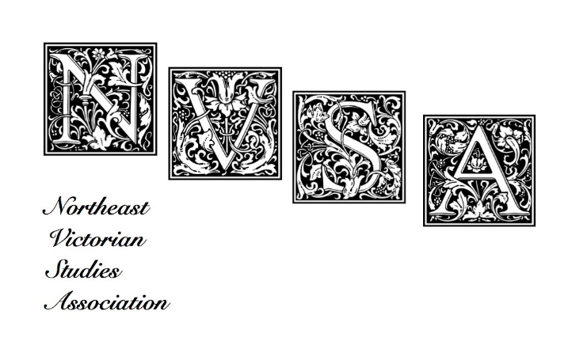

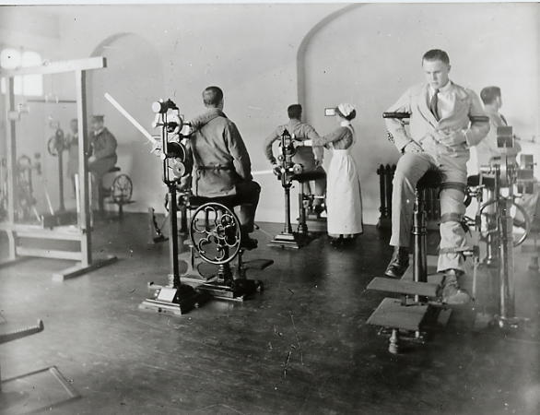

Recovery
Northeast Victorian Studies Association
Johns Hopkins University
April 8-10, 2022

